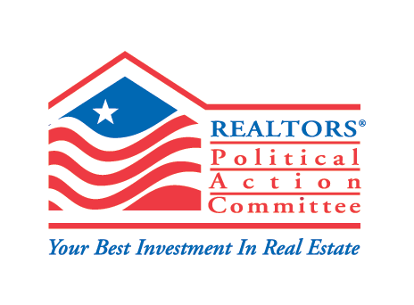

**For further information contact**

**Patrick Newton, 202-383-1290**

**pnewton@nar.realtor**

**Realtors® Political Action Committee Announces Support for Dan Newhouse**

**for U.S. House of Representatives**

Olympia, Washington (July 20, 2022) — Following a recommendation from the Washington Realtors**®** PAC, the National Association of Realtors**®** Political Action Committee (RPAC) announced its support today for Congressman Dan Newhouse in his re-election campaign for Washington’s 4th Congressional District.

“Throughout his career, Congressman Newhouse has shown a willingness to listen to, acknowledge, and address the needs of the communities he’s served,” said Katherine Carey, chairwoman of the Washington Realtors® Political Action Committee. “He has long championed issues important to the real estate industry, like protecting private property rights and safeguarding the dream of homeownership. We’re confident he will continue to represent our values and stand up for Realtors® and property owners in the U.S. House of Representatives.”

RPAC, the political action committee of the National Association of Realtors®, follows strict guidelines to ensure candidates are supported based on their defense of private property rights and other policies important to the real estate industry. Candidate endorsements and contributions were recommended and approved by Washington Realtors®  RPAC Trustees and RPAC.

The National Association of Realtors® is America’s largest trade association, representing more than 1.5 million members involved in all aspects of the residential and commercial real estate industries.

**###**



REALTOR® is a registered collective

membership mark which may be used only by

real estate professionals who are members of

the NATIONAL ASSOCIATION Of REALTORS®

and subscribe to its strict Code of Ethics.